March is National Nutrition Month!
Lots of different things affect how healthy we are including what we eat and how active we are. Food plays a huge role in keeping us healthy. Eating a variety of foods to get the right vitamins and nutrients is important. A healthy eating routine can help boost your health today and, in the years, to come. Did you know nutrients in everyday foods may help boost your body’s natural defenses?
Some Immunity-Boosting Foods Include:
- Yogurt, contains helpful germs called probiotics that help improve the way your body uses food
- Fruits & Veggies, that are high in Vitamin C, such as citrus fruits, strawberries, broccoli and bell peppers help boost your immune system
- Lean Meats boost your body’s disease fighting systems
- Fish and Walnuts are full of Omega-3s, which help to fight illness
“Let food be thy medicine and medicine be thy food.”
-Hippocrates
_______________________________________________________________________________________________
Have fun experimenting with different fruits in this tasty smoothie
Ingredients
- 3 cups strawberries, frozen (or other frozen fruit)
- 2 cups milk, low-fat
- 1 banana, large
- 1 cup yogurt (plain or vanilla)
Directions
- Defrost the frozen fruit just enough so that it will blend easily.
2) Pour the milk into the blender.
3) Add the pieces of frozen fruit to the milk in the blender.
4) Add the banana and yogurt.
5) Blend until smooth, about 30-45 seconds.

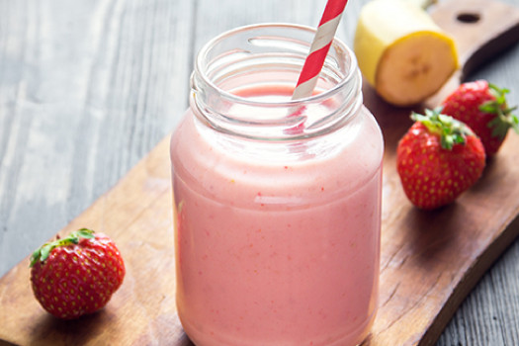
References
- Griffin, M.R. (n.d.). Immunity-boosting snacks for kids. https://www.webmd.com/parenting/features/immune-system#1
- U.S. Department of Agriculture. (n.d.). Fruit smoothie II. https://www.myplate.gov/recipes/supplemental-nutrition-assistance-program-snap/fruit-smoothie-ii

